**Visvesvaraya Technological University**

**Belagavi, Karnataka, 590 014.**



**AICTE Activity Point Programme on**

**Domain: “Doubling the Village Income”**

**Topic: “Handicraft Industry”**

(Non-Credit Activity of 2 Weeks (80-90 hours))

Submitted in partial fulfillment of the requirements for the award of

**Bachelor of Engineering in**

**Computer Science and Engineering Semester IV**

**Academic Year 2021-22**

***Department of Computer Science & Engineering***

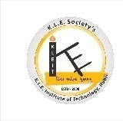K. L. E. SOCIETY’S

**K. L. E. INSTITUTE OF TECHNOLOGY,**

Opp. Airport, Gokul, Hubballi-580 030

Phone: 0836-2232681 Website: [www.kleit.ac.in](http://www.kleit.ac.in/)

## AICTE Activity Point Programme on

**Domain: “Doubling the Village Income”**

**Topic: “Handicraft Industry”**

**Sub-topics Page No.**

1] Introduction 3

2] Literature Survey 5

3] Government Initiatives 8

4] Government Body 8

5] Approach: Kasuti Embroidery 9

6] Key Challenges 13

7] Strategies 15

8] Sakhi Saphalya Crafts

Producer Company 17

9] Conclusion 18

10] References 19

**Group Members**

1] Sagar Hiremath 2KE20CS076

2] Shrinivas Raddi 2KE20CS096

3] Shrusti A. Kori 2KE20CS097

4] Srushti Raghavendra Shettar 2KE20CS101

5] Sumant Shivakumar Nidoni 2KE20CS102

6] Veerendra Patil 2KE20CS106

7] Vinayshree P. Hiremath 2KE20CS107

8] Sahana R. M 2KE20CS115

**Coordinator Head of the Department Principal**

**DOUBLING THE INCOME OF VILLAGE THROUGH HANDICRAFT INDUSTRY**

**1] INTRODUCTION**

Handicraft is one of the most important sectors in the Indian economy employing more than seven million people. The country produces woodware, artmetal wares, handprinted textiles, embroidered goods, zari goods, imitation jewellery, sculptures, pottery, glassware, attars, agarbattis, etc. The Handcraft industry in India is dominated by female artisans with over 56% of the total artisans. The country has 744 handicraft clusters employing nearly 212,000 artisans and offering over 35,000 products. Surat, Bareilly, Varanasi, Agra, Hyderabad, Lucknow, Chennai, and Mumbai are among the major clusters. Most of the manufacturing units are in rural and small towns, and there is enormous market potential in all Indian cities and abroad.

India is home to >3,000 craft forms with artisans, spread across the country, working with papier-mâché in Jammu and Kashmir, thangka painting in Ladakh and Himachal Pradesh, phulkari and bagh textiles in Punjab, brassware in Haryana, basket-weaving in Uttaranchal, chikankari and zardozi work in Uttar Pradesh, blue pottery and block printing in Rajasthan, ajrak and kite making in Gujarat, gond painting in Madhya Pradesh, terracotta products and warli art in Maharashtra, crochet and lace work in Goa, sandalwood carving and banjara embroidery in Karnataka, vallam boat making in Kerala, thanjuvar kalamkari in Tamil Nadu, telia rumal and kondapalli toys in Andhra Pradesh, ikat work in Telangana, cane baskets in Nagaland, sikki grass products in Odisha, dhokra work in Jharkhand, kantha and patachitra crafts in West Bengal, madhubani paintings and mulberry silk products in Bihar, choktse tables in Sikkim, eri silk products in Assam and bamboo products in Chhattisgarh, Arunachal Pradesh, Manipur, Mizoram, Tripura and Meghalaya.

Significant advances in the availability of handicraft products on various online portals are bolstering market growth in India. Handicrafts are becoming increasingly popular as the country's travel and tourism industry grows. Tourists spend significant money on souvenirs and other craft items, expanding the opportunity for local artisans and craftspeople to produce and sell efficient handicrafts. Furthermore, rising demand for handmade décor accessories in homes, offices, and restaurants and rising demand from the gifting industry are propelling market growth. The sector is economically viable with low capital investment, high value addition ratio and high export potential.

The Indian Handicraft Industry is showing continuous growth rate of 20% every year. Handicrafts industry is one of the important segments of decentralize sector in India.

According to the national census of handicrafts, undertaken by the National Council for Applied Economic Research the value of handicrafts produced last year were of Rs.17970.12 Crore.

* India’s contribution in world market is 1.2%.
* The total exports of crafts items: - Rs. 23504.42 Cr.
* Industry’s share in India's exports: - 1.51 %

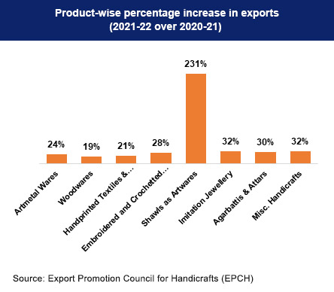

*Fig no. 1.1: Bar Graph depicting Product-wise percentage*

*increase in exports (2021-22 over 2020-21)*

**2] LITERATURE SURVEY**

The handloom and handicraft industry has been the backbone of India’s rural economy for decades. It is one of the largest employment generators after agriculture, providing a key means of livelihood to the country’s rural and urban population. The sector functions on a self-sustaining business model, with craftsmen often growing their own raw materials and is well known for being a pioneer of environment-friendly zero-waste practices.

According to official estimates, India is home to 7 million artisans. However, data from unofficial sources indicates that the artisan strength is as high as 200 million. The wide nature of this range and disparity in the number is due to the informal and unorganised character of this sector.

With this wide range of craft skills and the number of artisans in the country, India has the potential to make this sector a multi-billion-dollar industry. Handicraft exports from India reached Rs. 25,706.3 crore (US$ 3.5 billion) in 2019–20.

**Export Trend**

India is one of the largest handicrafts exporting country and a clear leader in the homemade carpet segment both in terms of volume and value. In May 2022, the total handicraft export, excluding handmade carpets from India was US$ 120.06 million, a 1.01% increase from April 2022. During 2021-22, the total exports of Indian handicrafts were valued at US$ 4.35 billion, a 25.7% increase from the previous year. Over the past three years, the export of handmade goods, especially carpets, has grown steadily. India accounts for roughly 40% of global exports of handmade carpets. Carpet exports from India totalled US$ 1.37 billion in FY20. Between April 2020-February 2021, total carpet exports totalled US$ 1.33 billion. Major goods exported by India are Handmade woolen, woodwares, embroidered & crocheted goods, art metal ware, hand printed textile & scarves, agarbatties & attars, zari & zari goods, and imitation jewellery. Handicraft export of various segments from April 2020 to January 2021 stood as follows, woodwares at US$ 611.48 million, embroidered & crocheted goods at US$ 463.13 million, art metal wares at US$ 353.92 million, handprinted textiles and scarves at US$ 239.73 million, imitation jewellery at US$ 144.19 million, miscellaneous handicrafts at US$ 714.67 million.

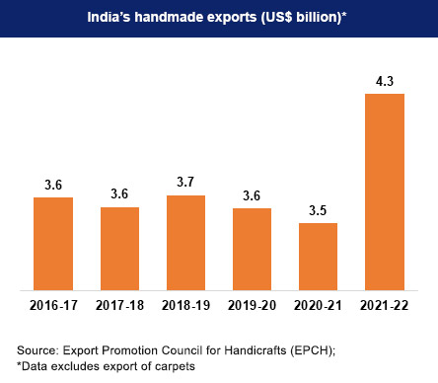

*Fig no. 2.1: Bar Graph depicting India’s handmade exports spanning*

*from 2016-17 to 2021-22*

**Export Destinations**

Demand for Indian handicraft products has constantly been increasing in foreign markets due to their individuality and great beauty. The major handicraft export destination for India are USA, the UK, LAC, Australia, Canada, France, Germany, Italy, Japan, Netherlands, the UAE and Switzerland. USA is the top importer of Indian handicrafts with a share of 38% of the total exports during 2020-21. India exports carpet to over 70 countries worldwide, primarily to USA, Australia, and Europe. The largest carpet export destinations for India are USA, Germany, the UK, and Australia with a share of about 57%, 6%, 5% and 5%, respectively.

USA is a significant buyer of handprinted textiles, zari woods, embroidered goods, imitation jewellery, and shawls. Carpet export to USA stood at over US$ 1.2 billion in 2021-22. The UK is a customer of Indian handicrafts, purchasing art items, crocheted items, handmade handicrafts, wood wares, and imitation jewellery. The country has also been a major importer of Indian handmade carpets. UAE is one of the major buyers of handprinted textiles, embroidery goods and art metal ware.

Handprinted textiles, imitation jewellery, embroidery items, and art metals are popular purchases in Germany and the country purchased carpets worth US$ 116.64 million in 2021-22.

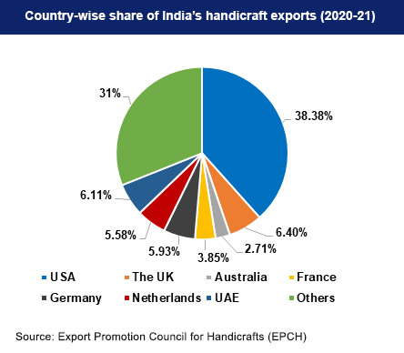

*Fig no. 2.2: Pie Chart depicting Country-wise share of India’s handcraft*

*exports (2020-21)*

**3] GOVERNMENT INITIATIVES**

**National Handicraft Development Programme (NHDP)**

The programme's goal is to increase the knowledge of the entire handicrafts sector about new design trends and colour forecasts, in order to increase India’s exports by increasing the new design led product. The important component of this programme is carrying out surveys, upgrading design and technology, developing human resources, providing insurance and credit facilities to artisans, R&D, infrastructure development and marketing support activities.

**Comprehensive Handicrafts Cluster Development Scheme (CHCDS)**

CHCDS aims to assist artisans and entrepreneurs in establishing world-class units with modern infrastructure, cutting-edge technology, adequate training and human resource development inputs, market linkages, and production diversification.

Soft interventions such as baseline surveys and activity mapping, skill training, improved tool kits, marketing events, seminars, publicity, design workshops, capacity building, and so on will be provided through CHCDS. Common Facility Centers, Emporiums, Raw Material Banks, Trade Facilitation Centers, Common Production Centers, Design and Resource Centers will also be granted under the scheme.

In addition to several standard international marketing events, virtual marketing events have been organized to provide artisans with an international marketing platform. Domestic marketing events such as Gandhi Shilp Bazaar, Craft Bazaar, and Exhibitions are organized to provide artisans with a domestic marketing platform.

**4] GOVERNMENT BODY**

**Export Promotion Council for Handicrafts (EPCH)**

The EPCH was established under the Companies Act in 1986-87. The main objective of the council is to promote, support, protect, maintain and increase the export of handicrafts. The other activities of the council are knowledge dissemination, providing professional advice and support to members, organizing delegation visits and fairs, providing liaison between exporters and the government and carrying out awareness workshops.

**5] APPROACH: KASUTI EMBROIDERY**

Kasuti or Kashidakari embroidery dates back to the Chalukya period and was popularized throughout Karnataka. Kasuti is a sort of hand embroidery done with cotton threads on Ilkal and Kanchipuram sarees, which draws inspiration from traditional rangoli patterns found in Karnataka.

The technique itself is of such a nature that the designs will appear more or less the same regardless of which side they’re being viewed from, with no loose ends. These designs can appear throughout the body as well as the pallu, and can sometimes also be found on the borders of the saree. Typically, silk sarees are the traditional base, though some examples can be found on cotton, and lately there has been some deviation from the usage of only Kanchipuram silk and Ilkal sarees, though by far these are still the most common.

Kasuti embroidery has been granted the GI tag, but unlike most cases, this does not appear to be specifically tied to a particular place in Karnataka, with the tag being under the authority of the state government to use at its discretion.

Although it was first only done in the Dharwad region, over time, it has expanded into other parts of Karnataka and is now used throughout South India. Initially, this job was done only by women, and to date, women form a vital element of the cottage industry of Kasuti.

**History**

The term Kasuti is composed of ‘Kai’ which implies hand and ‘Suti’ that is a cotton thread. In the districts of Bijapur, Dharwar, Belgaum, Miraj, Sangli and Jamkhandi, the Kasuti embroidery is extremely famous. This form traditionally has been made with lightly coloured cotton threads solely in handwoven textiles with deeper colours. The Ilkal sarees are the classic Kasuti embroidery sarees. It was a custom in the past that the bride must have a black silk sari, known as Chandrakali sari with Kasuti’s work on it. Kunchi (bonnet and cape), lenga (skirt), seragu (Pallav of a sari), kusuba (bodice) and kulai are the five types of clothing items on which kasuti embroidery is used. Currently, it is also done on curtains, cushion covers and many other household articles of handwoven cloth.

**Types Of Stitches**

Kasuti embroidery patterns demand a long time, and typically require more than one artist to manoeuvre properly. In this type of artform, each thread is to be counted on the cloth. This approach ensures a very complex and gorgeous look of the finished artwork. Moreover, the patterns are stitched without using knots to ensure that both sides of the cloth look alike. Kasuti has four types of stitches: the gavanti stitch or double stitch, the muragi- or zig-zag stitch, the neygi or darning stitch and the stitch hent or cross-stitch.

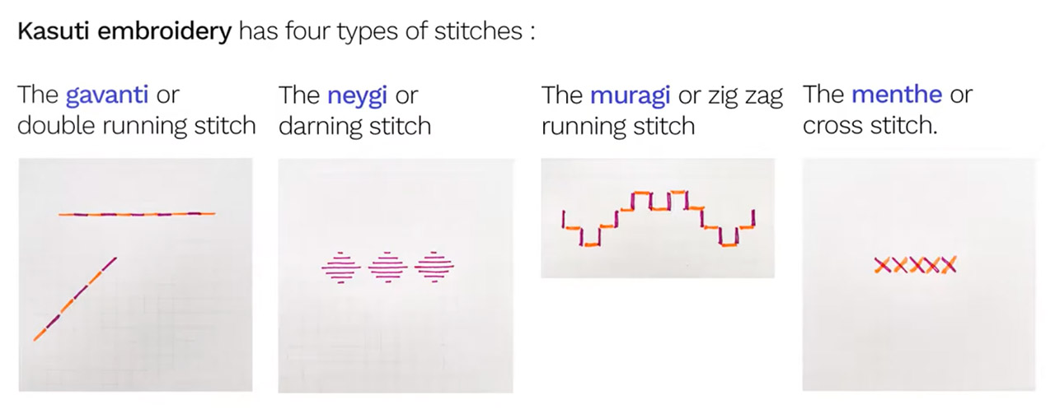

*Fig no. 5.1: Types of Stitches used in Kasuti Embroidery*

**Gavanti:** This is a double running line and back stitch. The name comes from Gaonti, which in the Kannada language means a knot. Most of the designs are geometrical since they are produced vertically, horizontally and diagonally. It is the most prevalent stitch and on both sides of the fabric the designs seem the same. On the way back while stitching, the lines or motifs should be finished by filling out the white areas in the loop.

**Neygi:** The Negi stitch is a common running or darning stitch. It has the impact of a woven design in general. Negi is in fact an offshoot of the word Ney, which means to weave in the language of Kannada. For larger designs, this stitch is employed by altering the stitch depending on the surface to be covered. The finished design looks like woven patterns and so the right and incorrect sides are not the same.

**Muragi:** Murgi resembles a ladder step, as the stitches are zigzag running stitches. It is alike Gavanti since they’re both neat with the design on both sides of the garment looking similar. The length of the stitches is consistent and the space between the stitches is identical.

**Menthe**: It is the standard cross stitch. The name seems to have come from the same word in the Kannada language meaning fenugreek seed. Menthe usually looks heavy and needs a great deal of thread. This stitch was therefore not used extensively. Many of the Kasuti labourers employ cross-stitch nowadays, which is not worked closely as was done formerly. The background sections of the designs are often covered using this menthe stich.

**Kasuti Embroidery Motifs & Patterns**

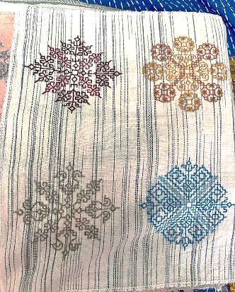

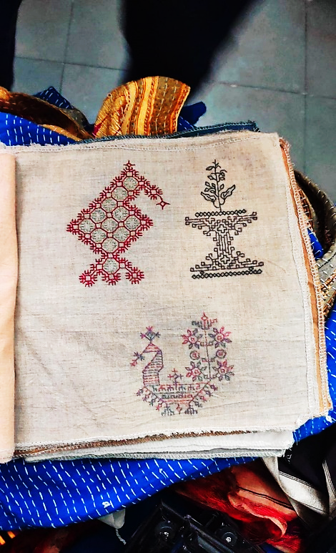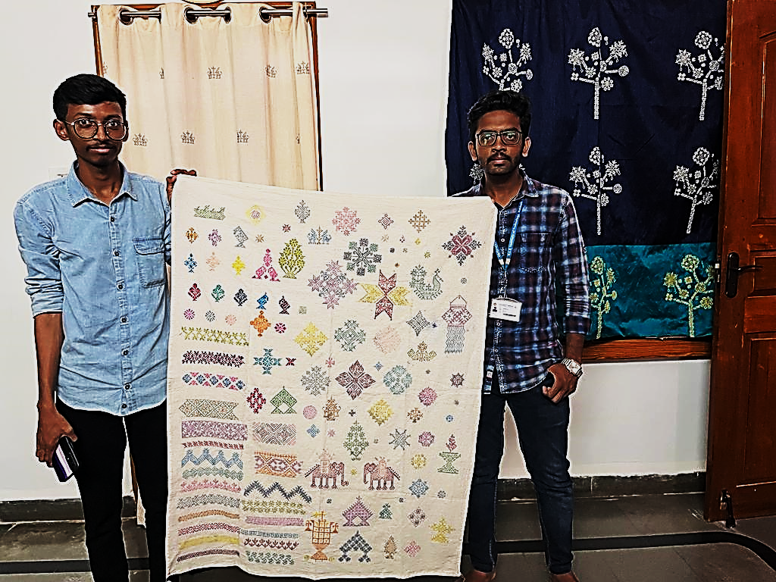

*Fig no. 5.2: Kasuti Embroidery Motifs & Patterns used at*

*Sakhi Saphalya Crafts Producer Co.*

The several sorts of patterns employed are another significant distinctive feature of this embroidery style. The themes in Kasuti that are commonly utilised are temple architecture, south India’s gopurams, lotus flowers, rath and palanquins, bird patterns like parrots, peacocks, swan and squirrels. The sacred bull, the elephant and the deer are the animal motifs used. Kasuti’s other designs include cow, cradle, flower pots and tulsi katte (katte means the space for the holy Tulsi plant). Horses, lions or tigers are rarely observed, but cats and dogs are never seen. Lotus is mainly used among the flower motifs. The motives may be light and scattered but that is highly unusual. Often, they are interconnected in incredibly gorgeous, three-dimensional designs with exquisite and creative appearances. Inspired rural styles are also very popular among various female embroiderers who like to create household sceneries in combination with stylised forms for wedding sarees. The important feature of Kasuti embroidery reveals a true artistic sense when it is multi-coloured with a harmonious blending.

**Threads Used In Kasuti Embroidery**

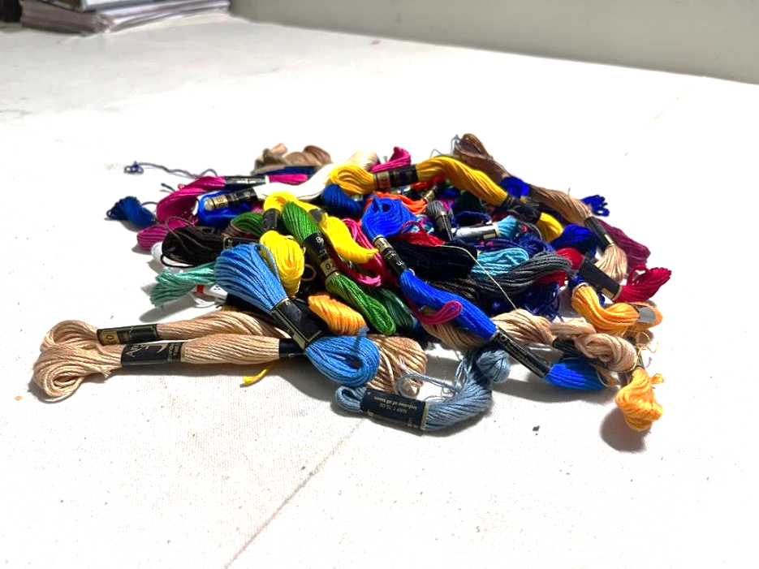

*Fig no. 5.3: Anchor threads used for Kasuti Embroidery work at*

*Sakhi Saphalya Crafts Producer Co.*

The cloth itself was pulled for the thread used in Kasuti in olden times. They are now getting Mysore silk threads to make the embroidery. The reason why silk threads are used is to ensure the surface seems flat.

Currently mercerized cotton threads like kohinoor and anchor thread, or pure, strong, fast-colored silk threads are used for the broding of Kasuti. It usually uses a single strand. A knot is never placed at the end of the thread, before or after the work ends.

Kasuti was always a domestic art. Traditionally, when Kasuti embroidered on the family’s clothes, it was a habit to give them as presents. The mother trained her daughter from a young age in this technique. It is a traditional art that passes from one generation to the next. The fine handwork, colour combinations and complex designs which machines have not yet been in a position to make have gathered favour in foreign countries.

Now Kasuti is made on clothing, sarees, pillow coverings, door curtains, cloth for the tables and other kinds of textiles. Some of the localities where Kasuti is still made include Dharwar, Hubli, Kalghatgi, Gadag and Mundargi.

**6] KEY CHALLENGES**

Indian handicrafts and traditional crafts showcase the rich heritage and true culture of our nation. With beautiful designs, the artisans carry a legacy of their land, myth, culture and carve their art into forms that can be forwarded to generations.

Indian artisans were highly regarded and rewarded until the outbreak of 19th century industrialization. However, the Indian Government, since independence has implemented various plans to secure this sector, the industrialization has been continued to affect artisans. Technological advancement is also a major reason behind the reduction of handcrafted products into machine made products that cost a little less as compared, this as a result taking Indian handicrafts industry is on the verge of extinction.

On the other hand, the contribution of Indian handicrafts cannot be neglected. The industry has offered employment to a large number of artisans from generation to generation. The condition of the industry in India has been changed now. Instead of higher potentialities, the sector is suffering from the acute decline in export business. Below are difficulties Indian artisans are facing:

1. **Processing And Procuring Raw Materials**

Earlier, raw materials used by artisans were largely accessible due to the close links between the evolution of crafts and locally available materials. Further, the Jajmani system, which mainly comprises artisanal caste and the village community to supply goods and services; offered artisans with access to community resources. Over the time, this traditional structure has been broken down along with competition from organized industry; artisans find it difficult to buy quality raw materials at a price they can afford to pay. In the absence of raw material banks, these local artisans are forced to rely on local traders who provide them raw materials against orders, at high prices, or switch to non-traditional raw materials.

1. **Production**

The techniques and the process of crafting vary from one craft to another; the production takes place in households, with all the family members get engaged in various aspects of the process. Even though there are organized artisans’ structures exist, those craftsmen typically produce within community settings. The production of handcrafted products is mostly seasonal, with crafts activity being balanced for the period of the harvest season, as most of the artisans is also engaged in agriculture to for their livelihood.

1. **Markets**

The market for hand crafted products can be understood as local, retail shops – high-end as well as mainstream, exhibitions and exports. Out of all these, local markets are still the most common market for many artisans. The new age markets, national as well as international, have grown with an expanding demand for products that have a story linked to them. However, such products are low in supply due to inefficiencies in the supply chain.

1. **Demand**

With the beginning of globalization and the availability of more affordable and varied products, the market is facing severe competition in the global market. These products are typically perceived as traditional, old-fashioned and antithetical to modern tastes. There have been lesser efforts made in order to reposition the image of handicrafts in India and build customer appreciation of the history and cultural identity associated with these products. Apart from that, there have been a few instances of traditional crafts being contemporized to fit with changing market patterns.

1. **Dominance of middlemen**

Although middlemen are necessary to enable effective market linkages, they often, if not always, exploit artisans by paying them a fraction of their fair wages.

**7] STRATERGIES**

**1) Training**

Skill upgradation and development in handicraft sector is an excellent approach for development of artisans, poverty reduction and providing income generation, which would also help in achievement of sustainable development goals.

**2)** **Recognise it as a source of supplementary income**

Since the craft sector is the second largest employer in rural India after agriculture, it is a source of supplementary income for the seasonal agricultural workers, who have limited alternative employment opportunities in the village. Access to economic independence through the handicraft sector can address the livelihood issues and would lead to income generation in rural areas.

**3) Conduct workshops**

At both the rural and urban levels, workshops should be organised that enhance the skills and also the knowledge of the people. Skill showcase, design education, creative and product development workshops can be followed up with pricing, marketing, branding, micro-finance etc. These workshops can help artisans eradicate the communication gap between the two representations of society and bring in a better understanding of demand and supply. It also initiates traditional art awareness.

**4) Professional marketing personnel**

To bring back art and handicrafts into the market, craftsmen and the artisans need to understand the modern market and its promotional strategies. To do the same professional marketing personnel can be employed, who help them to understand their space in the global market and then fix the price of their products, so as to get maximum profit & exposure to the global market.

**5) Removing the middlemen**

The artisans can collaborate with organisations like ‘Sakhi Saphalya Crafts Producer Co Ltd’, that eliminate the role of middlemen and help the artisans to sell their product at the global market for a fair price. They also provide training to the artisans.

1. **Making use of government schemes**

To address these challenges and to develop and promote the sector, the government's National Handicraft Development Programme is being implemented by the Office of the Development Commissioner (Handicrafts). Presenting the Union Budget 2021, Finance Minister Nirmala Sitharaman also proposed the exemption on import of duty-free items as an incentive to exporters of handicraft items to give a boost to the sector.

These are four schemes for empowering Indian handicrafts and artisans:

* + Ambedkar Hastshilp Vikas Yojna
* Mega cluster scheme
* Marketing support and services scheme
* Research and development scheme

**8] SAKHI SAPHALYA CRAFTS PRODUCER COMPANY**

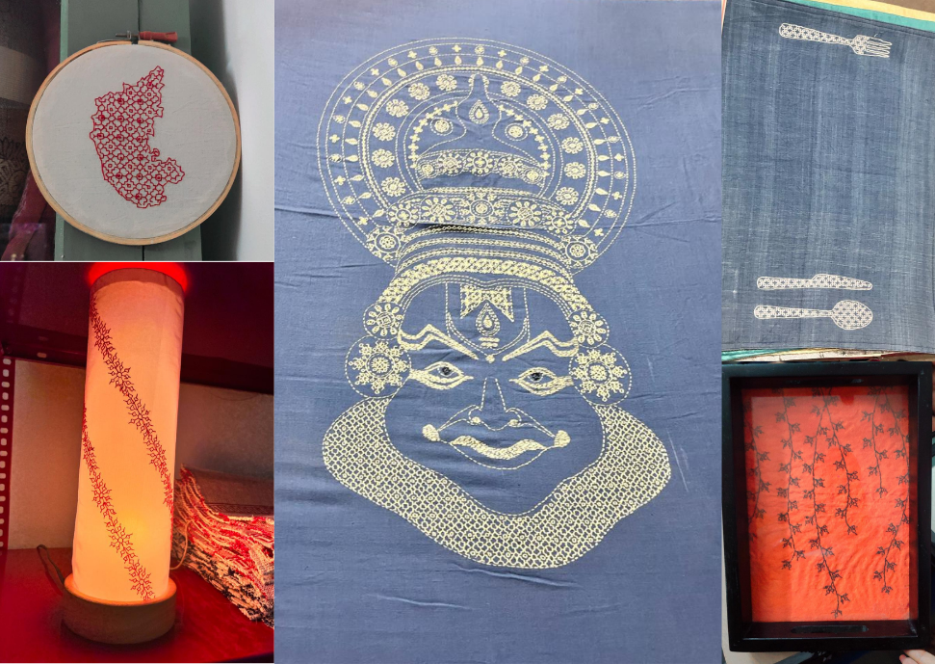

*Fig no. 8.1: Kasuti Embroidery works at Sakhi Saphalya Crafts Producer Co.*

It is a crafts producer company managed by women Kasuti hand embroidery artisans from rural areas of Dharwad District, Karnataka. A women-led crafts producer company, Sakhi Saphalya not only works toward sustaining the economy of the under-employed women but also looks into training them periodically. They work with many brands and designers, both local and international, they take the quality of their work seriously. Thus, they have been inviting consultants from the industry to familiarise their artisans with the demands of the urban market.

We had the pleasure to meet with Aparna Mam and her team, to discuss regarding the project particularly about the problems faced by the artisans and how their company helped them to overcome it. She informed us about the difficulties faced by the artisans due to COVID-19 Pandemic, wherein the woman being majority of the artisans had to step up to generate income as their husbands couldn’t work due to the strict quarantine measures. Even then only 72 artisans out of the 300 artisans could regularly work during the COVID time.

She also stated about the organization’s journey from an NGO to a Production company (in which the artisans are shareholders) so that the artisans could have higher earnings, help them have a stable income work and also connect to the global market. “The artisans are the ones who decide upon the pricing of their work based on the time spent as well as the complexity of the stitches involved” she informed. The company supplies the materials to the artisans who do the necessary work and the orders are dispatched to the respective organisations.

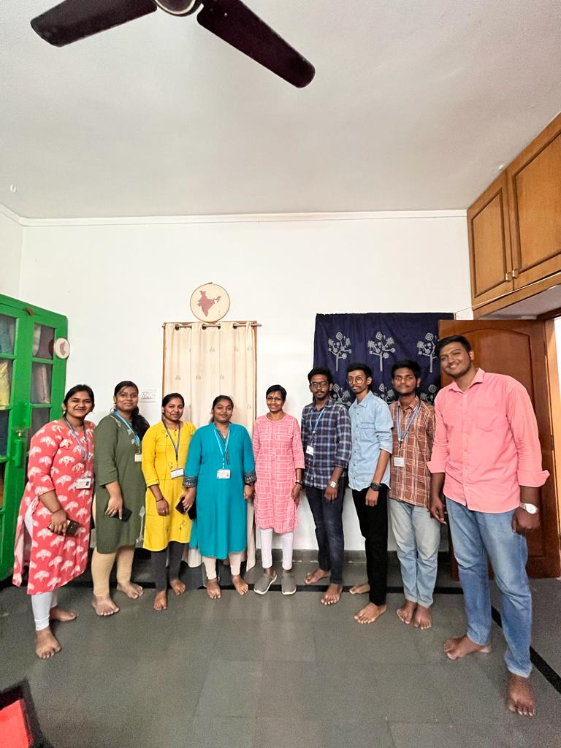

*Fig no. 8.2: Our Team with Aparna Mam at Sakhi Saphalya Crafts Producer Co.*

**9] CONCLUSION**

The tangible and intangible nature of India’s craft heritage, coupled with its regional uniqueness, presents the country with a competitive global advantage. The Indian craft sector has the scope to become a billion-dollar marketplace with the right support and business environment. Developing a systematic approach, which nurtures the intrinsic value of craft skills and opens avenues for product design and manufacturing will increase access to new markets. Alongside, capitalising on e-commerce for online visibility and operational efficiencies will prove to be a critical success factor as the sector evolves and gains further traction.

**10] REFERENCES**

* [Indian Handicrafts, Best Handicraft Products Manufacturers in India - IBEF](https://www.ibef.org/exports/handicrafts-industry-india)
* [India's Handicraft Crafts: A Sector Gaining Momentum | IBEF](https://www.ibef.org/blogs/india-s-handicraft-crafts-a-sector-gaining-momentum)
* [Trend analysis and problems & solutions of export of indian handicraf… (slideshare.net)](https://www.slideshare.net/vinay05722/trend-analysis-and-problems-solutions-of-export-of-indian-handicraft-industry)
* [Handlooms of Karnataka - Weaving Tradition of Generations (caleidoscope.in)](https://www.caleidoscope.in/art-culture/handlooms-of-karnataka)
* [Kasuti Embroidery - A Traditional Fabric Art of Karnataka (caleidoscope.in)](https://www.caleidoscope.in/art-culture/kasuti-embroidery-01)
* [5 factors depleting the Indian handicraft industry - Indian Retailer](https://www.indianretailer.com/article/sector-watch/fashion/5-factors-depleting-the-Indian-handicraft-industry.a5382)
* [Role of handicraft in economy and challenges faced Issues and Analysis @ abhipedia Powered by ABHIMANU IAS](https://abhipedia.abhimanu.com/Article/IAS/MTIzNjky/Role-of-handicraft-in-economy-and-challenges-faced-Economic-Affairs-IAS#:~:text=Challenges%20faced%20by%20Handicrafts%20industry%3A%201%20Low%20productivity%3A,with%20these%20markets.%204%20Fragmented%20value%20chain%3A%20)
* [Art is losing its grip: Here are 8 ways to bring back the handicraft industry - India Today](https://www.indiatoday.in/education-today/jobs-and-careers/story/art-craft-356171-2016-12-07)
* [4 schemes for empowering Indian handicrafts and artisans (yourstory.com)](https://yourstory.com/smbstory/indian-handicrafts-artisans-schemes-boost-exports)
* Instagram account @sakhi.saphalya